1.List 3 key differences between Ethernet cables and fiber optic cables, and give one real-world example where each type would be used (for example, home WiFi router, data center, college campus backbone).

Key Differences between Ethernet Cables and Fiber Optic Cables
Feature | Ethernet Cable | Fiber Optic Cable
Material | Uses copper wires to transmit data | Uses glass or plastic fibers to transmit data as light
Speed and Distance | Suitable for shorter distances (up to about 100 meters) | Supports very high speeds over long distances (several kilometers)
Interference | Can be affected by electromagnetic interference | Not affected by electromagnetic interference

Real-World Examples:
- Ethernet Cable: Used to connect a home WiFi router to a desktop computer or gaming console.
- Fiber Optic Cable: Used as the backbone network in a college campus to connect different buildings.
2.Draw and label a diagram showing the internal wiring of a straight-through Ethernet cable (use T568B wiring standard), indicating the color of each wire and its pin number.

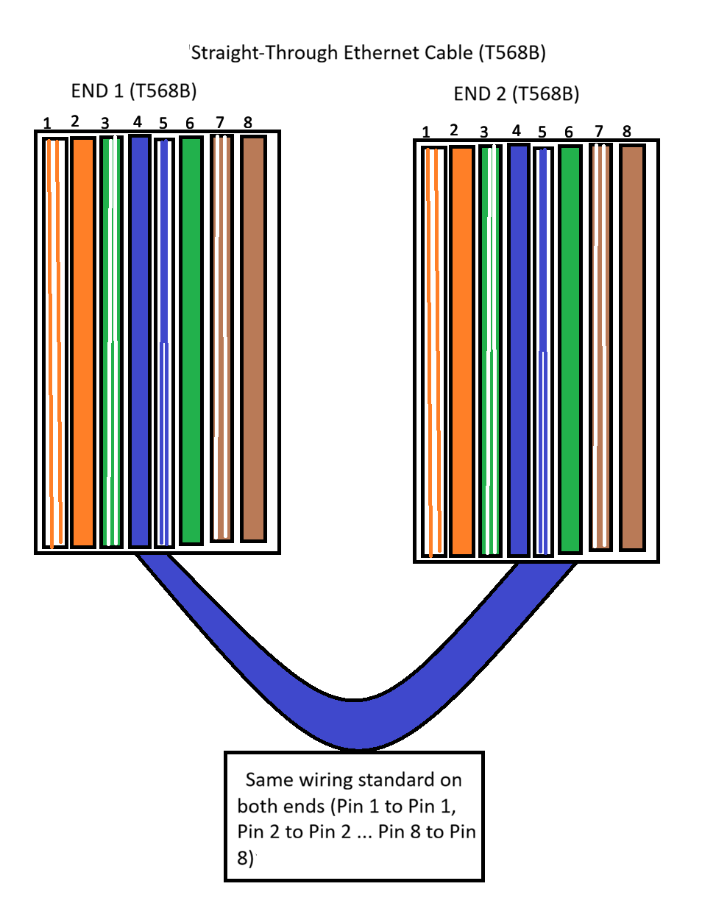
3.Watch a YouTube video demonstrating how to use an RJ45 crimper, then write a step-by-step guide (in your own words) on how to attach an RJ45 connector to a CAT6 cable.

Step-by-Step Guide to Attach an RJ45 Connector to a CAT6 Cable
- First, take a CAT6 cable and use a cable stripper to remove about 2-3 cm of the outer insulation from one end of the cable.
- After removing the insulation, untwist the wire pairs carefully and straighten all eight wires.
- Arrange the wires according to the T568B wiring standard:
White/Orange, Orange, White/Green, Blue, White/Blue, Green, White/Brown, Brown.
- Hold the wires firmly and trim their ends evenly using a cutter so that all wires are of the same length.
- Insert the wires carefully into the RJ45 connector, making sure that each wire goes into the correct slot and reaches the end of the connector.
- Check once again that the wire order is correct and that the cable jacket is slightly inside the connector.
- Place the RJ45 connector into the RJ45 crimping tool and press the handles firmly to crimp the connector onto the cable.
- Finally, test the cable using a network cable tester to ensure that all connections are working properly.
4.Imagine you are setting up a gaming café with 10 PCs for LAN gaming. Decide which cable type (Ethernet or fiber optics) and which tool (RJ45 crimper or fiber cleaver) you would use, and explain your choices in 3-4 sentences.<br><br><em><strong>Hint:</strong> Consider speed, distance, and budget for your answer.</em>

->If I were setting up a gaming café with 10 PCs for LAN gaming, I would use Ethernet cables because the PCs would be placed close to each other. Ethernet cables provide good speed for gaming and are also more affordable than fiber optic cables. I would use an RJ45 crimper to attach RJ45 connectors to the Ethernet cables. This setup would be cost-effective, easy to install, and suitable for a small gaming café.

